Speed Live Upload Service Installation Process.

Before running the application make sure the .net 8 runtimes installed on the pc.
https://dotnet.microsoft.com/en-us/download/dotnet/8.0

- You have two folder now
- a. win service
- b. speechlive tray application
- open the tray application first and double click on "SpeechLiveUploader.Win.exe"

- Now create/copy paste the EnglishCopyComplete.wav and Sample_Local_Configuration.ini files inside
C:\ProgramData\SpeechLive Helper

- Open windows powershell as administrator.
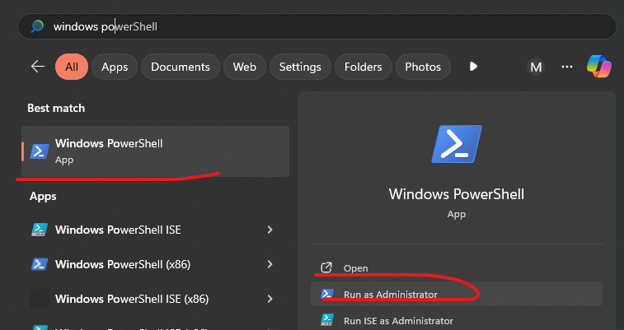
- Open the unzip folder and right click on file “SpeechLiveUploader.exe” and select “Copy as path”.
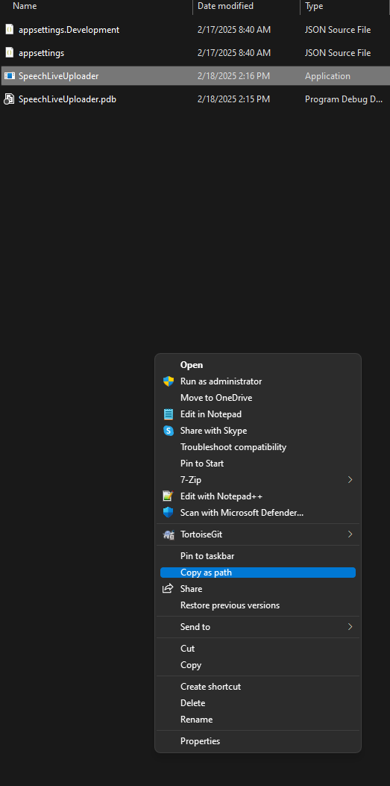
Now run the following command in windows powershell.
.\sc.exe create “Enter the service name you want to show in windows services” binpath =Paste the copied path here.

It will be like this [ this is on my pc so it will show your copied path here]

.\sc.exe create "Speech Live Uploader Service" binpath ="E:\Projects\Winforms\SpeechLiveUploader\SpeechLiveUploader\bin\Release\net8.0\publish\win-x64\SpeechLiveUploader.exe"

You should get a success message.
Now go to windows services.
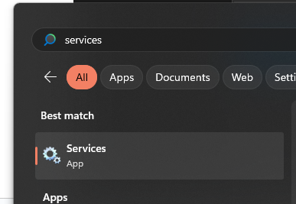

Find the service “Speech Live Uploader Service” or the name you given while creating the service in above powershell command.
And start it.
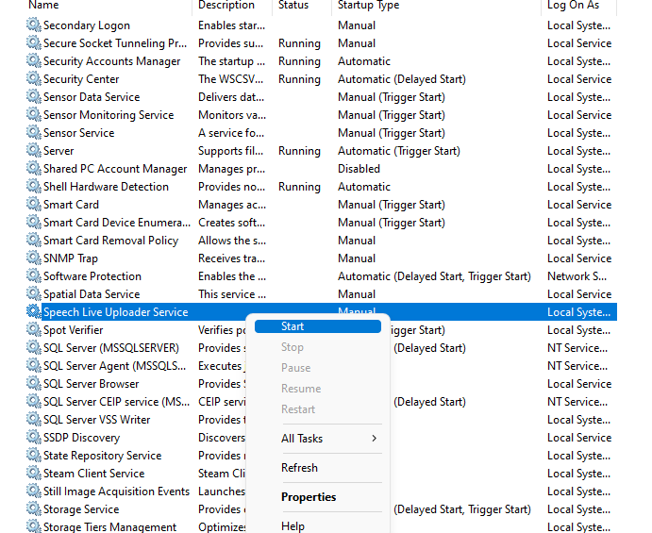

Once it start you can use the application, plug the USB or any external device. You can find the logs and working folder under C:\ProgramData\Speech Live Uploader

Note : if you want to delete the service first stop it from services, then just run the following command and windows powershell.

.\sc.exe delete “Speech Live Uploader Service"
Or use the name which you given for creating the service. And look at the powershell command.

